 | Course Name: Advanced Web Technology | EXPERIMENT NO. 6
 | Course Code: 20CP314P  Faculty: Komal Singh | Branch: CSE
 | Course Code: 20CP314P  Faculty: Komal Singh | Semester: VI
Submitted by: Harsh Shah
Roll no: 21BCP359

Objective: Working with properties in React
- In the commercial furniture web-application add products with information like image, price, color, manufacturer using react props.
App.js
import './App.css';
import Home from './Home';
import { BrowserRouter, Routes, Route } from 'react-router-dom';
import Task1and2 from './Task1and2/Task1and2';
import Task3and4 from './Task3and4/Task3and4';
function App() {
return (
<div>
<BrowserRouter>
<Routes>
<Route path="/" element={<Home />}> </Route>
<Route path="/student" element={<Task1and2 />}> </Route>
<Route path="/furniture" element={<Task3and4/>}> </Route>
</Routes>
</BrowserRouter>
</div>
);
}
export default App;

Home.jsx
import './App.css';
import React from 'react'
import { Link } from 'react-router-dom';
const Home = () => {
return (
<div>
<header className="App-header" style={{ width: '100vw' }}>
<h2>Practical 6</h2>
<Link to="/student" className='link'>Go to Task 1 and 2</Link>
<br />
<Link to="/furniture" className='link'>Go to Task 3 and 4</Link>
</header>
</div>
)
}
export default Home;

Task3and4.js
import "../App.css";
import Furniture from "./Furniture";

function Task3and4() {
return (
<div className="grid-container App-header App">
<Furniture
itemName="Linanas"
itemPrice="29990"
itemImg="https://www.ikea.com/in/en/images/products/linanaes-3-seat-sofa-with-chaise-longue-vissle-dark-grey__1013909_pe829463_s5.jpg?f=xxs"
color="Gray"
manufacturer="Ravi Furnitures"
/>

<Furniture
itemName="Nodeland"
itemPrice="15990"
itemImg="https://www.ikea.com/in/en/images/products/nodeland-wardrobe-with-3-doors-medium-brown__0836934_pe778612_s5.jpg?f=xxs"
color="Brown"
manufacturer="New india Furnitures"
/>

<Furniture
itemName="Nolmyra"
itemPrice="3990"
itemImg="https://www.ikea.com/in/en/images/products/renberget-swivel-chair-bomstad-black__1025981_pe834276_s5.jpg?f=xxs"
color="Black"
manufacturer="IKEA"
/>

<Furniture
itemName="Oxberg"
itemPrice="3690"
itemImg="https://www.ikea.com/in/en/images/products/billy-oxberg-bookcase-with-door-white__1094849_pe863651_s5.jpg?f=xxs"
color="White"
manufacturer="he Interior Hub"
/>

<Furniture
itemName="Knarrevik"
itemPrice="899"
itemImg="https://www.ikea.com/in/en/images/products/knarrevik-bedside-table-black__0858302_pe669481_s5.jpg?f=xxs"
color="Black"
manufacturer="Furniture Nest"
/>

<Furniture
itemName="Tufjord"
itemPrice="42990"
itemImg="https://www.ikea.com/in/en/images/products/knarrevik-bedside-table-black__0858302_pe669481_s5.jpg?f=xxs"
color="Black"
manufacturer="IKEA"
/>
</div>
);
}
export default Task3and4;

Furniture.js
import "../App.css";

function Furniture(props) {
return (
<div className="grid-item">
<img src={props.itemImg} alt={props.itemName} className="itemImg" />
<h3 className="itemName">{props.itemName}</h3>
<p className="itemPrice">Color: {props.color}</p>
<p className="itemPrice">Rs. {props.itemPrice}</p>
<p className="itemPrice">Manufaturer: {props.manufacturer}</p>
</div>
);
}
"IKEA",
};

export default Furniture;

Output
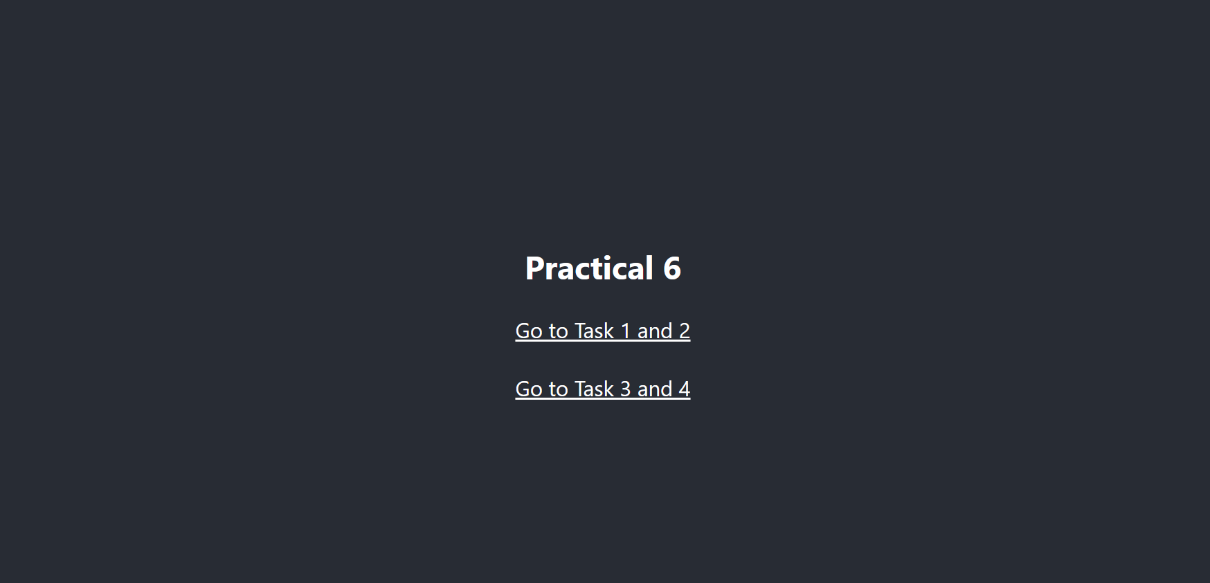
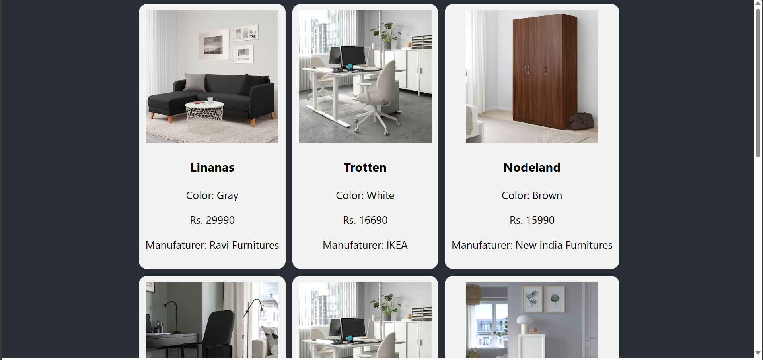
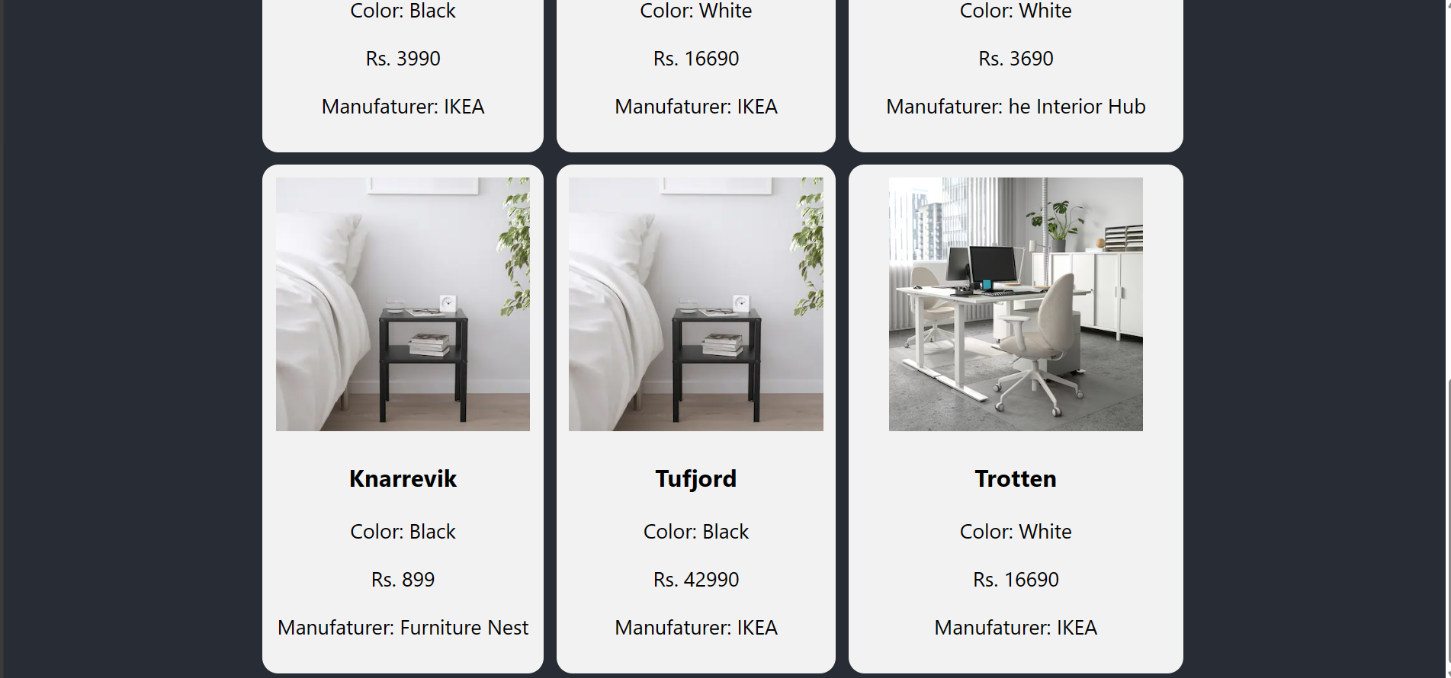

- Add default values for all the furniture properties which are displayed in absence of corresponding information.
Modified Task3and4.js
import "../App.css";
import Furniture from "./Furniture";

function Task3and4() {
return (
<div className="grid-container App-header App">
<Furniture
itemName="Linanas"
itemPrice="29990"
itemImg="https://www.ikea.com/in/en/images/products/linanaes-3-seat-sofa-with-chaise-longue-vissle-dark-grey__1013909_pe829463_s5.jpg?f=xxs"
color="Gray"
manufacturer="Ravi Furnitures"
/>

<Furniture />

<Furniture
itemName="Nodeland"
itemPrice="15990"
itemImg="https://www.ikea.com/in/en/images/products/nodeland-wardrobe-with-3-doors-medium-brown__0836934_pe778612_s5.jpg?f=xxs"
color="Brown"
manufacturer="New india Furnitures"
/>

<Furniture
itemName="Nolmyra"
itemPrice="3990"
itemImg="https://www.ikea.com/in/en/images/products/renberget-swivel-chair-bomstad-black__1025981_pe834276_s5.jpg?f=xxs"
color="Black"
manufacturer="IKEA"
/>

<Furniture />

<Furniture
itemName="Oxberg"
itemPrice="3690"
itemImg="https://www.ikea.com/in/en/images/products/billy-oxberg-bookcase-with-door-white__1094849_pe863651_s5.jpg?f=xxs"
color="White"
manufacturer="he Interior Hub"
/>

<Furniture
itemName="Knarrevik"
itemPrice="899"
itemImg="https://www.ikea.com/in/en/images/products/knarrevik-bedside-table-black__0858302_pe669481_s5.jpg?f=xxs"
color="Black"
manufacturer="Furniture Nest"
/>

<Furniture
itemName="Tufjord"
itemPrice="42990"
itemImg="https://www.ikea.com/in/en/images/products/knarrevik-bedside-table-black__0858302_pe669481_s5.jpg?f=xxs"
color="Black"
manufacturer="IKEA"
/>

<Furniture />
</div>
);
}
export default Task3and4;

Modified Furniture.js
import "../App.css";

function Furniture(props) {
return (
<div className="grid-item">
<img src={props.itemImg} alt={props.itemName} className="itemImg" />
<h3 className="itemName">{props.itemName}</h3>
<p className="itemPrice">Color: {props.color}</p>
<p className="itemPrice">Rs. {props.itemPrice}</p>
<p className="itemPrice">Manufaturer: {props.manufacturer}</p>
</div>
);
}

Furniture.defaultProps = {
itemName: "Trotten",
itemPrice: "16690",
itemImg:
"https://www.ikea.com/in/en/images/products/trotten-desk-sit-stand-white__1040109_pe840587_s5.jpg?f=xxs",
color: "White",
manufacturer: "IKEA",
};
export default Furniture;

Output
